Create a table named student and populate the table as shown in the table.  
The table contains the marks of 10 students for 3 subjects(Physics, Chemistry, Mathematics).The total marks for physics and chemistry is 25.while for mathematics it is 50.The pass mark for physics and chemistry is 12 and for mathematics it is 25.A student is awarded a ‘Pass’ if he has passed all the subjects.

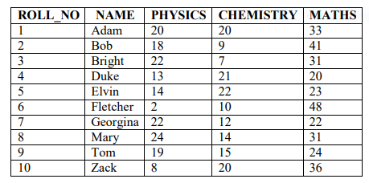

CREATE TABLE STUDENT(ROLL_NO int, NAME varchar(30), PHYSICS int, CHEMISTRY int, MATHS int );

|  |
| --- |
| INSERT INTO STUDENT VALUES(1 ,'Adam',20,20,33); |
|  |

|  |
| --- |
| INSERT INTO STUDENT VALUES(2 ,'Bob',18,9,41); |
|  |

|  |
| --- |
| INSERT INTO STUDENT VALUES(3 ,'Bright',22,7,31); |
|  |

|  |
| --- |
| INSERT INTO STUDENT VALUES(4 ,'Duke',13,21,20); |
|  |

|  |
| --- |
| INSERT INTO STUDENT VALUES(5 ,'Elvin',14,22,23); |
|  |

|  |
| --- |
| INSERT INTO STUDENT VALUES(6 ,'Fletcher',2,10,48); |
|  |

|  |
| --- |
| INSERT INTO STUDENT VALUES(7 ,'Georgina',22,12,22); |
|  |

|  |
| --- |
| INSERT INTO STUDENT VALUES(8 ,'Mary',24,14,31); |
|  |

|  |
| --- |
| INSERT INTO STUDENT VALUES(9 ,'Tom',19,15,24); |
|  |

INSERT INTO STUDENT VALUES(10 ,'Zack',8,20,36);



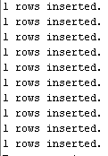

1. Find the class average for the subject ‘Physics’

SELECT AVG(PHYSICS) FROM STUDENT;



1. Find the highest marks for mathematics (To be displayed ashighest_marks_maths).

SELECT MAX(MATHS) As HIGHEST_MARKS_MATHEMATICS FROM STUDENT;



1. Find the lowest marks for chemistry(To be displayed aslowest_mark_chemistry)

SELECT MIN(CHEMISTRY) As LOWEST_MARKS_CHEMISTRY FROM STUDENT;



1. Find the total number of students who has got a ‘pass’ in physics.

SELECT COUNT(PHYSICS) FROM STUDENT WHERE PHYSICS>11;



1. Generate the list of students who have passed in all the subjects

SELECT * FROM STUDENT WHERE PHYSICS>11 AND CHEMISTRY>11 AND MATHS>24 ;



1. Generate a ranklist for the class. Indicate Pass/Fail. Ranking based on total marks obtained by the students.

SELECT * FROM STUDENT

ORDER BY TOTALMARK DESC;

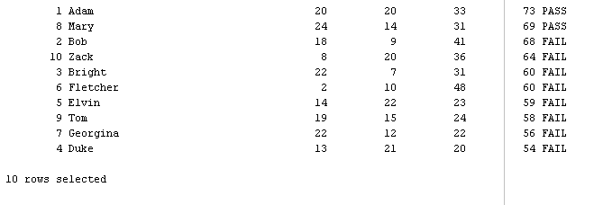

1. Find pass percentage of the class for mathematics

SELECT MAX((SELECT COUNT(MATHS) FROM STUDENT WHERE MATHS>24)/(SELECT COUNT(*) FROM STUDENT)*100)

FROM STUDENT;

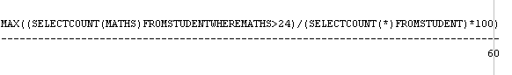

1. Find the overall pass percentage for all class.

SELECT MAX((SELECT COUNT(*) FROM STUDENT WHERE RESULT='PASS')/(SELECT COUNT(*) FROM STUDENT)*100)

FROM STUDENT;



1. Find the class average.

SELECT AVG(TOTALMARK) FROM STUDENT;

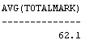

1. Find the total number of students who have got a Pass.

SELECT COUNT(*) FROM STUDENT WHERE RESULT='PASS';



Sample  
Generate a ranklist for the class. Indicate Pass/Fail. Ranking based on total marks obtained by the students  
